10000/10000 [==============================] - 4s 358us/sample - loss: 0.0053 - acc: 0.9736

The testing accuracy metric for 1 batch_size is [0.005270638895555274, 0.9736]

---------------------------------------------------

10000/10000 [==============================] - 3s 346us/sample - loss: 0.1598 - acc: 0.1942

The testing accuracy metric for 128 batch_size is [0.1598273904800415, 0.1942]

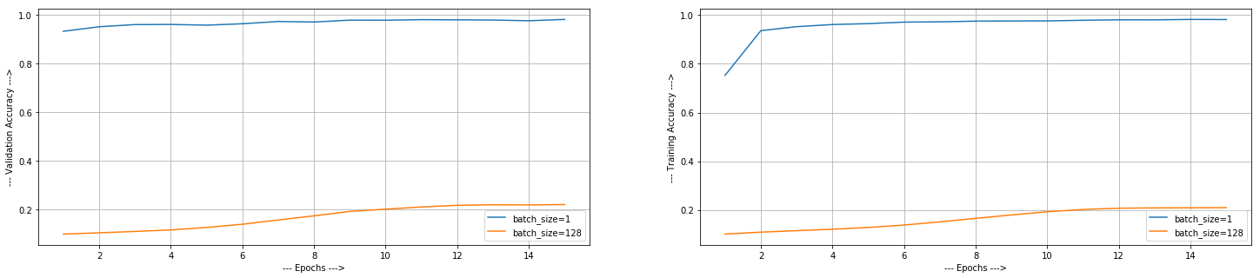

**OBSERVATIONS:**

1. **Batch Size Vs Accuracy**: More batch size means less iterations in one epoch. We observed that as we decrease the batch size, the accuracy increases and stabilizes around 98%. Both validation and training accuracy increased indicating that the model didn’t overfit. As we can see from above data, testing accuracy also increased. We can see that the model with batch size 128 didn’t even cross 30% accuracy after 15 epochs. Giving it more epochs will increase the accuracy.